ICRERA 2025

14th INTERNATIONAL CONFERENCE ON RENEWABLE ENERGY RESEARCH AND APPLICATIONS
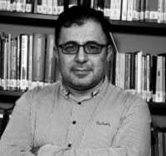
Assoc. Prof. Dr. Onder Eyecioglu
Bolu Abant Izzet Baysal University, Bolu, Türkiye

Paper ID : 496
Paper Title : Unsupervised Clustering Approaches to Analyze Electric Vehicle Charging Behavior for Smart Grid Integration
Bio :
Dr. Onder Eyecioglu is an Associate Professor in the Department of Computer Engineering at Bolu Abant Izzet Baysal University, where he also serves as the Vice Dean of the Faculty of Engineering. He received his Ph.D., Master of Science, and Bachelor of Science degrees in Physics from Yildiz Technical University. His doctoral research focused on computer simulations of the electronic structure of carbon nanotubes.
His primary research interests include quantum computing, nanotechnology, deep learning, machine learning, and parallel computing. Dr. Eyecioglu has led notable projects, including acting as the Executive Director for a TUBITAK project to develop the BxCom software package, which calculates radiation buildup factors.

